**Android Software Development**

DoItYourself-ECard

By

Jean-Jack Franji

March 17, 2014

Prepared for

Dr. Mahmoud El Samad

Instructor of Information System Development – CSCI490

**Table of contents**

**CHAPTER 1: Introduction** 3

1.1 Purpose 4

1.2 Application Purpose 4

1.3 Mission and Vision 4

1.4 Scope Statement 5

1.5 Business Point of View 5

1.6 Technical Point of View 5

1.7 Design Method 6

**CHAPTER 2: System Analysis** 7

2.1 Stakeholders 8

Chapter 1

Introduction

* 1. Purpose

The purpose of presenting this document is to include a detailed report and description of the DoItYourself-Ecard Application. The Project will mention the problem statement, purpose, scope, stakeholders, Interface Prototyping, Use Case Diagram, Class Diagram, Scenarios, how the application works and finally some end results about how to interact with the whole application.

* 1. DoItYourself-Ecard Application Purpose

Recently, it is noticeable that most of the people have shifted their focus from using desktop computers and now rely on their smartphones for their daily tasks. Usually on Facebook, people used to see when it’s their friend’s birthday to write on their wall to celebrate that occasion. Now, without any proper cell phone configuration people are tending to forget to send happy birthday to their friends, and loved ones because off today’s busy life schedule. My Application will offer you a way to sync your Facebook Friends list Birthday info and remind you to send them a birthday E-card including a message to share it with them in an easy and fast way.

* 1. Mission and Vision of the Application

**Mission**

We will constantly read the user’s opinion and reviews about the application and occasionally fix any reported bug and provide updates including more templates and a superior user experience.

**Vision**

We will be user oriented by integrating the application with social applications and provide many ways to share the customized E-card in a fast and convenient manner.

* 1. Scope Statement

The main purpose that motivated me to choose such topic is mentioned below:

* Using this application the person can never miss out their friend’s birthday.
* It will provide an efficient way to remind the user to send a graphical image known as E-card including a body message to whoever they want.
* The user can also send an E-card for many other occasions such as funerals, marriage, recovering from a hospital, congratulations, graduation and many more.
* The user will be able to customize the background, the header, include an image and a body message.
* The ability to share the customized E-card with social apps like Facebook, Twitter, Instagram, Email or simply save it in your gallery and share it later!
* A very friendly user interface where the user can interact and have a pleasant experience while preparing the E-card.
  1. Business Point of View

In order to use this application, the intended user must install this application free of charge from the Official Play store for Android. The application is completely free of charge and it optionally requires the user to enter their Facebook credentials to retrieve the friend list birthday info.

* 1. Technical Point of View

The DoItYourself-Ecard is composed of a client-side application which can run on android smartphones and tablets. The client is advised to allow the application to interact with Facebook to provide a better user experience and notify them of their friend’s birthday. For every custom made E-card the structure will be saved in a small local database so the user can view the history of their sent E-cards. The application will ask for the user’s full name in order to use it while sending and e-card by email.

* 1. Design Method

**Software Engineering Method**

The application will be based on an object-oriented approach. Also for the System Design UML will be used for a graphical representation concerning the Database. Throughout the project I will be using the **FAST Method** - (Framework for the Application of Systems Thinking).

|  |  |  |  |  |
| --- | --- | --- | --- | --- |
| **FAST Phases** | **Classic Phases** | | | |
|  | Project Initiation | System Analysis | System Design | System Implementation |
| Scope Definition | X |  |  |  |
| Problem Analysis | X | X |  |  |
| Requirements Analysis |  | X |  |  |
| Logical Design |  | X |  |  |
| Decision Analysis | Decision and Transition Phase | | | |
| Physical Design and Integration |  |  | X |  |
| Construction and Testing |  |  | X | X |
| Installation and Delivery |  |  |  | X |

**Software’s used for analysis and design**

The Following Software’s were used to implement this project:

* Microsoft Project 2013: Designing the Time Table
* Balsamiq Mockups: Graphical User Interface Prototyping
* SmartDraw 2013: use case diagram, class diagram, ER Model

Chapter 2

System Analysis

* 1. Stakeholders

DoItYourself-Ecard Application Stakeholders List:

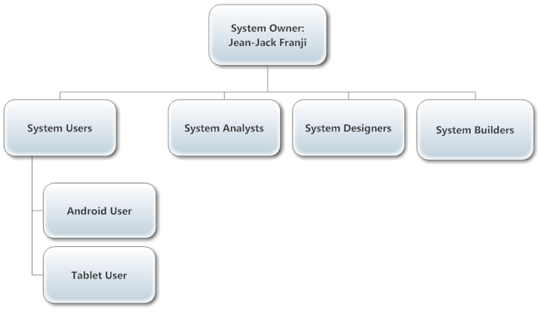

A stakeholder is a person or a group in an organization that has a role in the development of the project and is directly or indirectly affected by the completion process of the whole project.

The End user will install the application and use it to create a customized E-card by using the End-user Graphical User Interface to interact with the application. After the user completes the design of the E-card, he will be able to share it via many social applications. The user must either be an Android Smartphone user or an Android Tablet User in order to have access to the application.